STEPS TO INSTALL ANACONDA

1. Go to https://www.anaconda.com/download/

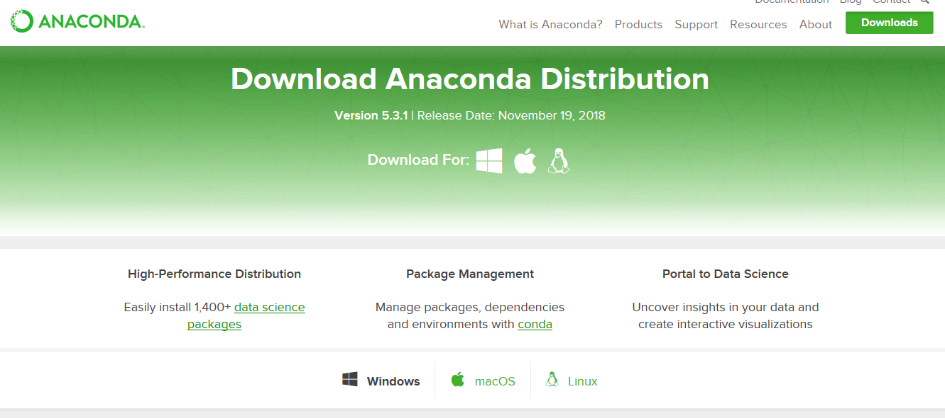

2)click on download anaconda for windows

3)click on the latest python version

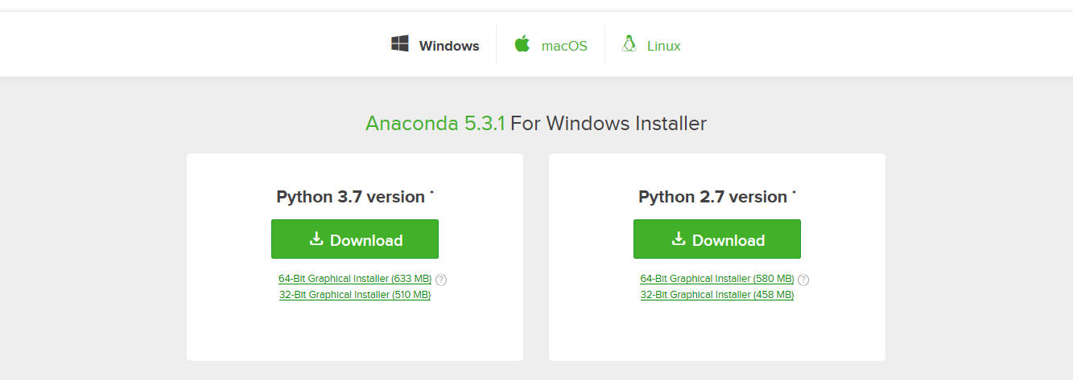

4) save the download file (big file around 631 mb)

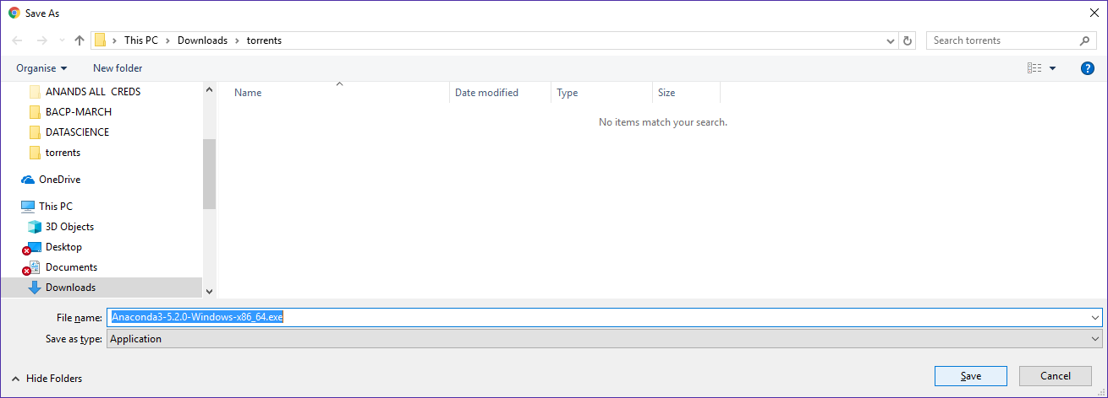

5) install the downloaded file –click on next 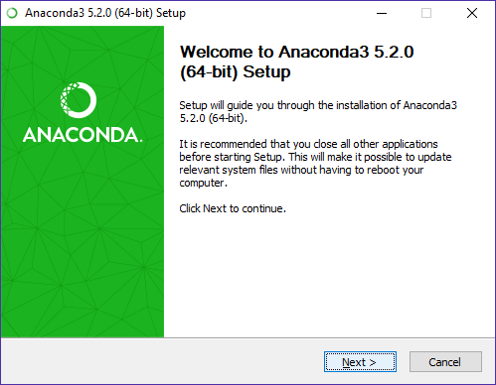

6) click on I Agree

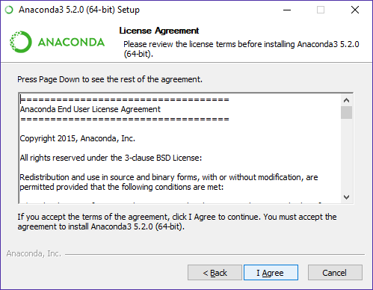

7) click on “Just Me” or “All users” as per your choice and click on “Next”

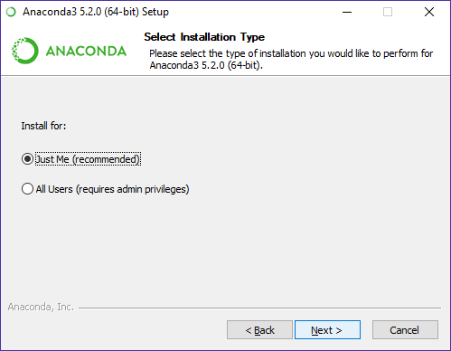

8)give the required path for the directory to install anaconda

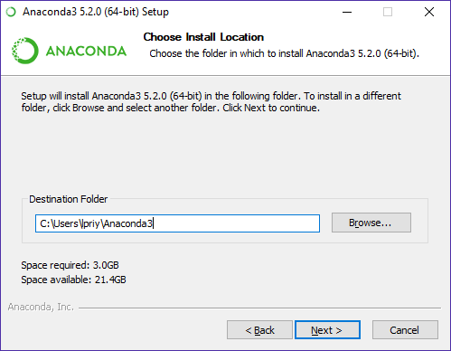

9) just follow instructions as below

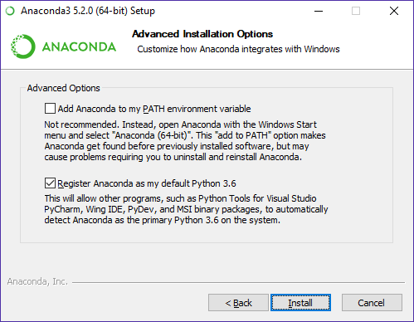

10) installation starts (takes time)

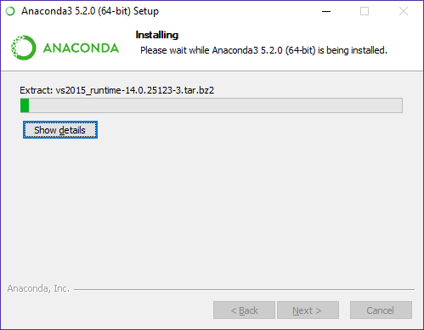

11) after the installation is complete

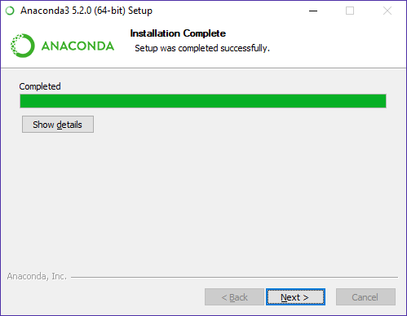

12 )click on next

13) in the ensuing dialog box, you can choose to install “Microsoft vscode” by clicking on “install Microsoft vscode” . if you do not want to install it click on skip

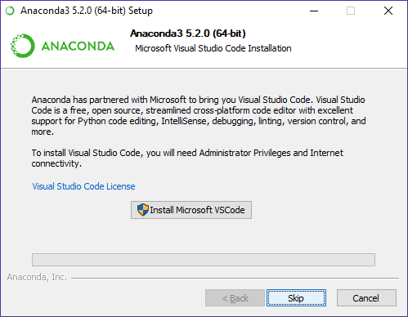

14)

Click on finish

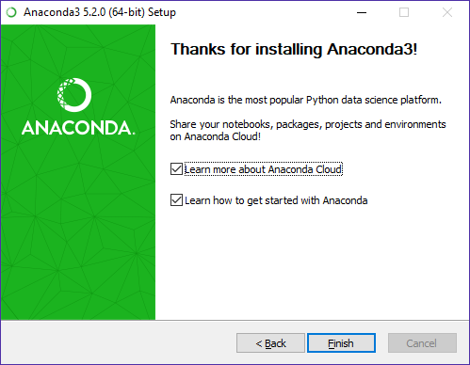

Using Jupyter

1. Click on windows Start
2. Click on anaconda 3 (64 bit or 32 bit depending on your windows os)

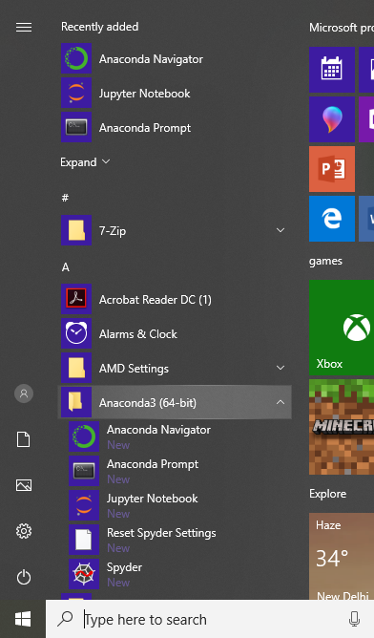

1. Click on jupyter notebook

Jupyter will run a command prompt as below and open a new tab in your web browser

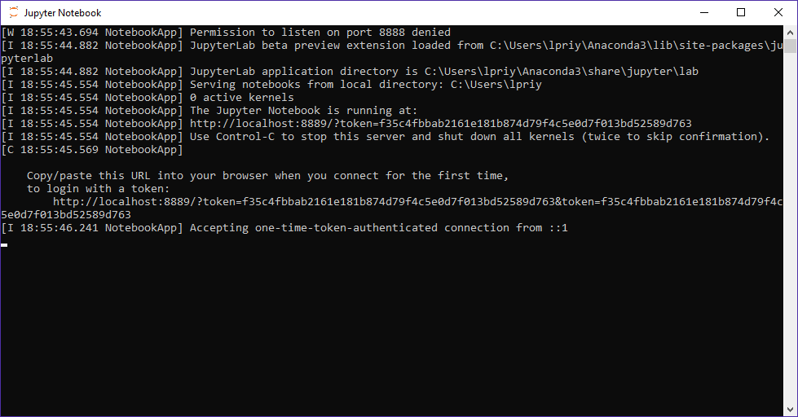

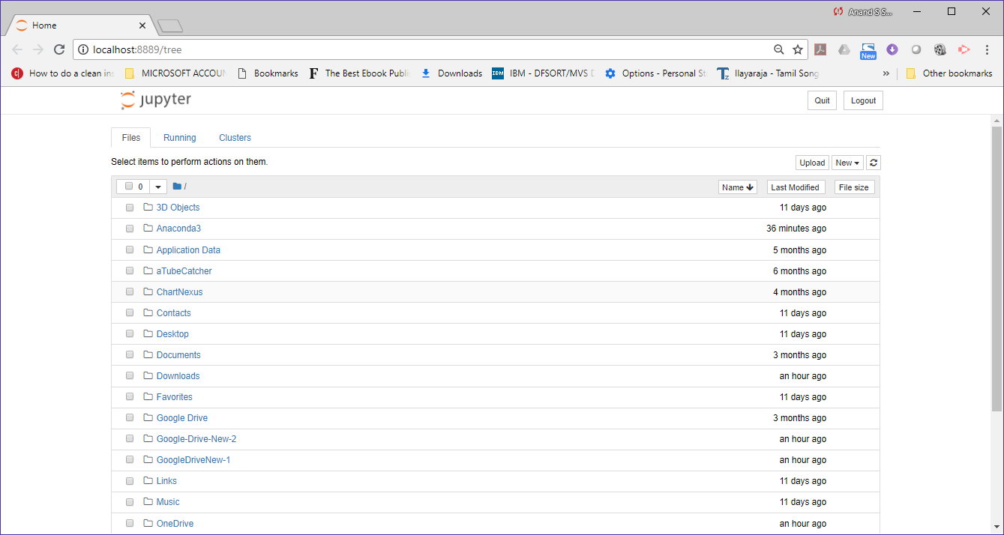

1. To open a new Jupyter notebook

Click on “New” drop down in the top right corner



Click here choose python 3

Change name of notebook here

1. A new jupyter note book opens as below

